CHRIST AND HIS KINGDOM
The 1000-Year Millennial Reign of the King, No. 18
Rev. 19:1 – 20:15
Part Two

Drawing Near: MacArthur, p. 115

“John’s vision of the last days turns a corner here, when the King of Kings returns to rule and reign in righteousness!” The Family of God has much to look forward to here.

The Context: MacArthur, p. 115

The Keys to the Text: See our handout on the three main views regarding the
duration and nature of the Millennium. 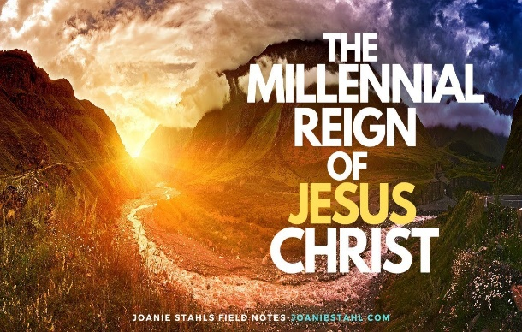
The Text: Rev. 20:1 – 15, Part Two

The Exposition:

Verses: 1-6 Interlude: The Thousand Years of the Dragon’s Binding and the Martyr’s Reign

Bottomless Pit (Greek, The Abyss) (1)

Temporary, demonic incarceration; awaiting the Lake of Fire.

ILL: Luke 8:26-33

ILL: Compare 9:1-2, 11:7; 17:8 and 20:1, 3

Laid hold (2)

Satan + his army of innumerable demonic spirits, or demons (12:4)

Dragon (2)

ILL: Rev. 12:3

Serpent of old (2)

John references the Genesis account of the Garden of Eden

Genesis 3:1-6

Paul punctuates Satan’s cunningness & ability to deceive humans

2 Corinthians 11:3

Timothy is reminded of Satan’s deceptiveness in the Garden of Eden

2 Timothy 2:13

Application: As the Family of God, we need to guard our minds and hearts so we are not deceived by the Serpent of Old.

A Thousand Years (2)

Figurative, Literal, or both?

1. Figurative use of the phrase, a Thousand Years

> Psalm 90:4 The Brevity or Shortness of human life

> 2 Peter 3:8 God’s Perspective on Time

2. Literal use of the phrase, a Thousand Years

MacArthur said it is used 6 times in the Revelation.

Compare Rev. 20:2-7 where it is used once in each verse.

This literal, One Thousand Year Reign of Jesus Christ on Earth will be awesome!

Bottomless Pit (3)

Occurs 7 times in the Revelation of Jesus Christ

Compare 9:1, 2, 11; 11:7; 17:8; 20:1, 2
Released for a little while (3)

Almighty God sovereignly releases Satan, the first Fallen Angel, and the Leader of the insurrection, for a very brief time, to complete his permitted uprising.

ILL: Insurrection- “an act or instance of rising in arms or open rebellion against an established government or authority,” Random House Kernerman Webster's College Dictionary, © 2010 K Dictionaries Ltd. Copyright 2005, 1997, 1991 by Random House, Inc. All rights reserved.

The Souls of those who had been beheaded (4)

Compare Rev. 6:9; 18:24 and 19:2

The Gk. word for “beheaded” became widely used
in the 1st. Century for executed

His Mark (4)

Rev. 13:11-18

“name of the beast or the number of its name” (17). What is it? Since it is not revealed in God’s Word, it’s uncertain.

ILL: Power of the Mark

MacArthur quotes W. A. Criswell, who said: “A man who had lived under
Bulgaria’s communist regime remarked: You cannot understand and you cannot
know that the most terrible instrument of persecution ever devised is an innocent
ration card. You cannot buy and you cannot sell except according to that innocent
little card. If they please, you can be starved to death, and if they please, you can
be dispossessed of everything you have; for you cannot trade, and you cannot
buy, and you cannot sell, without permission,” John MacArthur, The MacArthur New Testament
Commentary (Chicago: Moody Press, 2000), 1:63.

Reigned (4)

reigned
ἐβασίλευσαν (ebasileusan)
Verb - Aorist Indicative Active - 3rd Person Plural
Strong's 936: (a) I rule, reign, (b) I reign over. From basileus; to rule.
https://biblehub.com/revelation/20-4.htm#lexicon

Question: Who is assisting Christ & reigning with Him?

1. Tribulation Believers (The Newly Saved & Martyred, Young Believers)
2. New Testament Believers (The Raptured, Glorified Born-Again Church)
3. Old Testament Believers (The Hebrews 11 + Saints)

Answer: The Redeemed, the Family of God, will be reigning with Jesus Christ

Compare 1 Cor. 6:2 and 2 Tim. 2:11-13

The Rest of the Dead (5)

Compare Rev. 20:12-13 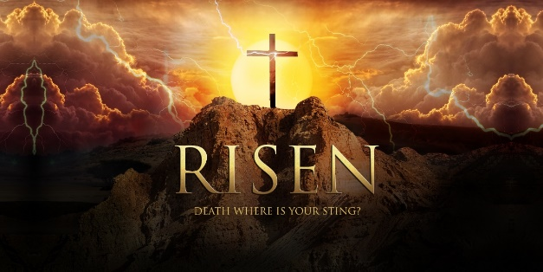
First Resurrection (5)
Two Resurrections:

> Daniel 12:1-2
> John 5:25-29
> Acts 24:10-15

Luke records Paul’s Declaration of Faith before Governor Felix at Caesarea; & Paul’s clarification of the two resurrections of:

a) “both the just,” (15)
b) “and the unjust,” (15, 21)

Question: What are these Two Resurrections?

1. Resurrection of Life

a) Luke 14:12-14

“The resurrection of the just,” (14)

b) I Corinthians 15:20 – 23

“those who belong to Christ,” (23)

c) Hebrews 11:35

“so that they might rise again to a better life”

2. Resurrections of Condemnation or Judgment

Blessed (6)

Compare Rev. 14:13 & 1:3

Therefore, blessed are those who:

1. Read the Revelation, (1:3a)
2. Hear the Revelation, (1:3b)
3. Keep the words in the Revelation, (1:3c)
4. “Die in the Lord,” (14:13)

Second Death (6)

God punctuates this horrific place by highlighting it 4 times

Compare Rev. 2:11; 20:6, 14 and 21:8

As His Witnesses, (Acts 1:8) we’re called to warn everyone that rejecting Christ will be costly. Let’s testify for Christ to all who will listen. That’s our Calling.

Verses: 7-10 God Defeat and Destroys the Dragon and Its Gathered Armies

Satan . . . Released (7)

God sovereignly and temporarily releases this wicked angel called Satan. He will spearhead the insurrectionists who are in disbelief and rebellion against Jesus Christ, the Universe’s Final Authority.

Gog and Magog (8)

Who is Gog and what is Magog?

Gog is mentioned 9 times in Scripture. The first is in the genealogy of the 12 Tribes of Israel (I Chronicles 1:1 - 9:44), in 5:4. In Ezekiel 38-39, God declares judgment on Gog, in the land of Magog, saying, “I am against you, O Gog, chief prince of Meshech and Tubal,” (38:1-3).

ILL: Commenting on this, the ESVSBftn on Ezekiel 38:2 clarifies, “In rabbinic literature and the Targums,* Gog and Magog are often seen as leaders of a great attack on Israel in a future messianic age.” Commenting future, the explanatory note continues, “In the NT, Gog and Magog are the names of the nations led by Satan to attack Jerusalem at the end of the “thousand years” (Rev. 20:8).”

* “The Aramaic translation of the Bible [Genesis - Malachi]. It forms a part of the Jewish traditional literature, and in its inception is as early as the time of the Second Temple,” https://www.jewishencyclopedia.com/articles/14248-targum Beloved City 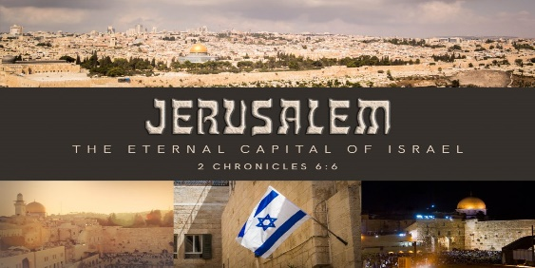

Jerusalem, the Capital during the Christ’s Millennial Reign.

ILL: Compare 2 Chronicles 6:1-6 with Isaiah 24:23

ILL: ESVSBftn on Psalm 78

“This is a historical Psalm . . .”

ILL: Psalm 78: 67-68

Some have accused God of being partial. This is impossible for 2 reasons.

1. The Word of God declares that God is impartial

James 3:17

2. The Word of God commands Believers to be impartial.

I Timothy 5:21

Therefore, there is no room in Christianity for favoritism or partiality.

Fire (9)

Compare Elijah, in 1 Kings 18:36-39 with 2 Kings 1:10, 12

Compare Lot, in Luke 17:9

Deceived (10)

Notice Rev. 16:14 “demonic spirits performing signs . . . Kings of
the whole world”

This is Worldwide and Global deception from Satan & his hordes of
wicked deceivers.

Tormented Day and Night (10)

Compare v 10 with Rev. 14:11

Our Righteous & Just God will give wicked angels & wicked men
what they deserve.

Verses: 11-15 The Last Judgment and the Destruction of Death, the Last Enemy

Great White Throne (11)
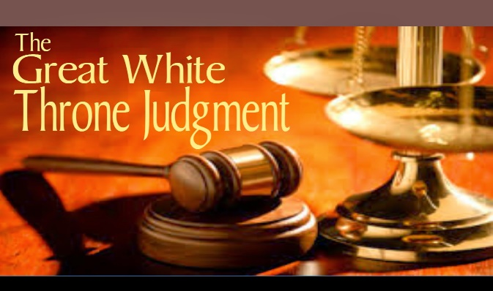

Fifty times God’s Judgment Throne is declared in His Word.

Compare & Consider: 4:2-3, 9; 5:1, 7, 13; 6:16; 7:10, 15; 21:5-7.
Earth and the Heaven Fled Away (11)

ILL: Joel 2:10-11 (Post-exile, 586 BC)

ILL: Haggai 2:6 (520 BC)

ILL: Hebrews 12:26-29 (Pre-70 AD, mentions Tim. 13:23)

Our Human Race has been sufficiently warned of God’s Judgment.

Standing Before God / the Throne (12)

Bar of Divine Justice

ILL: And just as it is appointed for man to die once, and after that comes judgment,” (Hebrews 10:27, (ESV).

Books (12)

ILL: Daniel 7:9-10

ILL: ESVSBftn for 7:9-12, “The scene depicts in powerful imagery a . . .”

Book of Life (12)
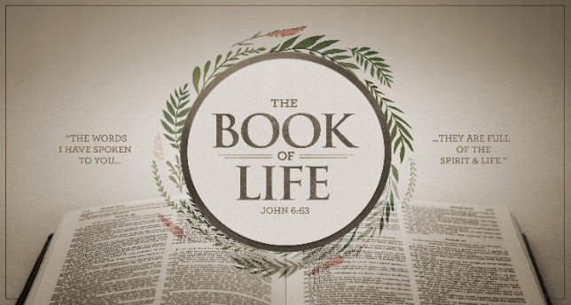

The Roll of the Redeemed

ILL: “When the Roll is Called up Yonder I’ll be There,” lyrics.
James Milton Black USA 1856-1938 Born in South Hill, NY, Black was an American hymn composer, choir leader and Sunday school teacher. He worked, lived, and died in Williamsport, PA.” https://hymnary.org/person/Black_JM

1 When the trumpet of the Lord shall sound and time shall be no more,
And the morning breaks, eternal, bright and fair;
When the saved of earth shall gather over on the other shore,
And the roll is called up yonder, I'll be there.
Refrain:
When the roll is called up yonder,
When the roll is called up yonder,
When the roll is called up yonder,
When the roll is called up yonder, I'll be there.
2 On that bright and cloudless morning when the dead in Christ shall rise,
And the glory of his resurrection share;
When his chosen ones shall gather to their home beyond the skies,
And the roll is called up yonder, I'll be there. [Refrain]
3 Let us labor for the Master from the dawn till setting sun;
Let us talk of all his wondrous love and care.
Then when all of life is over and our work on earth is done,
And the roll is called up yonder, I'll be there. [Refrain]

Judged according to their Works (12)

What does “Their Works” involve? MacArthur reminds us that these include our:

1. Thoughts, Luke 8:17, No More Secrets

2. Words, Matthew 12:37, Justification or Condemnation

3. Actions, Matthew 16:27, Some will Receive Rewards, Others Will Not

ILL: Memory Device: Do you remember TWA? Notice the acronym.

How Fair is This?

ILL: Matthew 5:48

ILL: ESVSBftn on 5:48

Are there varying degrees of suffering in hell?

Matthew 10:14-15; 11:22

Mark 12:38-40

Luke 12:47-48

The answer is not crystal clear, but the Scriptures infer that there might be. Some scholars believe that there is, including John MacArthur. This writer is uncertain, is praying for wisdom, while continuing in searching the Scriptures for answers.

Death and Hades (13)

Rev. 1:18

Rev. 9:1

Rev. 20:1

Application: As God’s Family, we need to avoid flirting with the Devil, take sin seriously, and keep our distance from the putridness on this Fallen Planet. As Christians, we need to be holy as He is Holy.

Your Reflections & Responses?

