ALL THINGS NEW
Paradise Regained, No. 19
Rev. 21:1 – 27
Part One

Drawing Near: MacArthur, p. 127

John closes his book with God’s promise of a new heaven and a new earth. Let’s discover together what this means and what we have to look forward to.

The Context: MacArthur, p. 127

Keys to the Text: 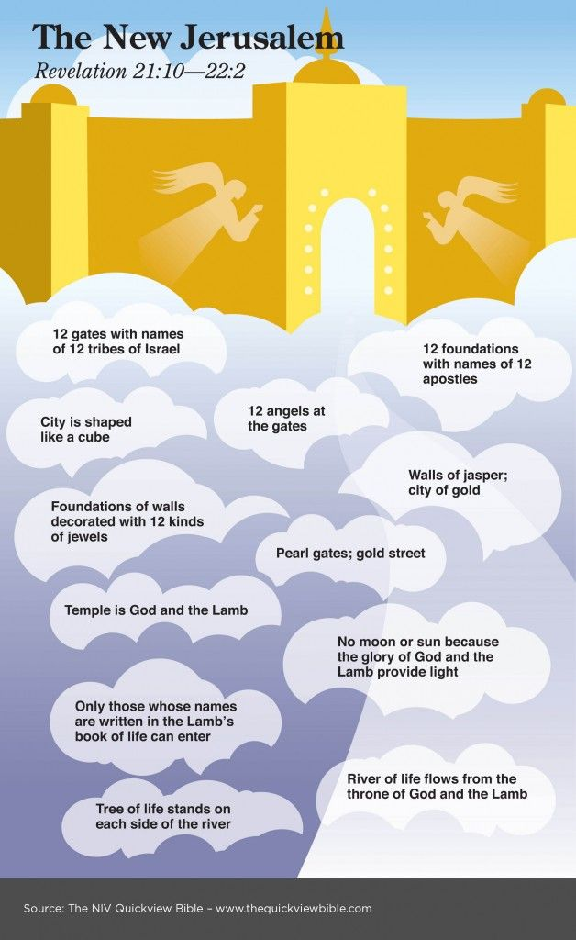

New Jerusalem, MacArthur, p. 128

The Bride, the Wife of the Lamb,
MacArthur, p. 128
The Text: Rev. 21:1 – 27, Part One

The Exposition:

Verses 1 – 8 The New Heaven and Earth,
Home of the Lamb’s Bride

A new heaven and a new earth (1)

Isaiah 65:17-25

ESVSBftn on 65:17-25

Isaiah 66:22-24

ESVSBftn on 66:22-23

ESVSBftn on 66:24

“The gospel is good news to the contrite but bad news to the rebellious,” ESVSBftn on 66:24, 1362.

No more sea (1)

1. Our current, water-based Planet (75% water), will be replaced with a new creation that “will have completely different climatic conditions,” (MacArthur).

2. Spiritually, the “sea from which the beast emerged,” (13:1) which is the “rebellion, chaos, and danger . . . will no longer threaten creation’s perfection,” ESVSBftn on 21:1, 2494.

New Jerusalem (2)

1. Collateral Teaching from the Author of Hebrews (pre-70 A.D.)

א. (Hebrew A) Hebrews 11:10; 13-16

ב. (Hebrew B) Hebrews 12:22

The writer contrasts “you have NOT come to,” (18) with “you
HAVE come to,” (22).

ג. (Hebrew C) Hebrews 13:14

2. (This draws on extensive OT Imagery of a new heavenly Zion / Jerusalem,” ESVSB, 12:22 footnote, p. 2384.

Compare Psalm 2:6; 3:4; 15:1 and 110:2

What does all of this mean for us today? MacArthur says:

“This is the capital city of heaven, a place of perfect holiness. It is seen “coming down out of heaven,” indicating it already existed; but it descends into the new heavens and new earth from its place on high,” MacArthur, John. The MacArthur Bible Commentary, Nashville: Thomas Nelson, 2005.

The tabernacle / dwelling place of God (3)

1. Leviticus 26:11-12

2. Second Corinthians 6:14-18

The Apostle Paul applies God’s promised blessing to Israel to the Church of Jesus
Christ. Therefore, today, the blessing is neither solely to Israel nor to the Church. Instead, today, the blessing is to the Redeemed, the entire redeemed Jew & Gentile Family of God.

Wipe away every tear (4)

Isaiah 25:8

True and faithful / trustworthy and true (5)

1. Rev. 3:14

2. Rev. 19:11

Water of life (6) The spring of the . . .

1. Rev. 7:17

2. Rev. 22:1

3. Rev. 22:17

Therefore, this spring of water appears to be the flowing and outpouring grace of God that quenches the thirst of Redeemed humanity freely and without human payment.

Isaiah promised this in 55:1-2. See ESVSBftn’s on 55:1 & 55:2.

Him who thirsts / To the thirty (6)

He who overcomes (7)

Question: Overcomes What / Who?

Answer: I John 5:4-5

Inherit / have this heritage (7)

Galatians 3:23-29

ILL: ESVSBftn on Gal. 3:26

Shall have their part in the lake which burns (8)

“This is a solemn, serious warning about the kinds of people who will be outcasts from the new heaven and the new earth in the lake of fire,” (MacArthur).

Application: This is why the Pastor leads us to pray every Sunday for those in
our lives who are rebelling against God. These people are refusing to submit to
God’s authority and to embrace our Resurrected Savior in grateful humility.

Verses 9 – 27 The New Jerusalem,
the Lamb’s Pure Bride
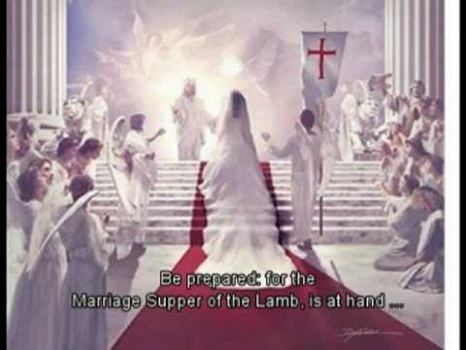
The Lamb’s wife (9)

Contrast this angel showing John- The Prostitute (17:1-3)
with this same angel showing John- The Bride (21:9ff).

Question: Who / what is The Prostitute?
and,
Who / what is The Bride?

Consider: 21:2; 19:6-9

Jasper, clear as crystal (11)

Diamond

Gold reed / measuring rod of gold (15)

About 10 foot

Measure the city (15)

Why measure? MacArthur suggests that measuring is one way to highlight ownership. It punctuates what belongs to God & God is measuring what is His.

ILL: Rev. 11:1

Length, breadth, and height (16)

Perfect Cube

Twelve thousand furlongs / stadia (16)

1400 x 1400 x 1400 = 200 million square miles. How large is this? The USA (3,797,000), Africa (11,730,000), Asia (17, 210,000), or Earth 196.9 million square miles.

One hundred and forty-four cubits (17)

72 yards, or 216 feet

Jasper (18)

Diamond (11)

Pure gold, like clear glass (18)

Transparent or clear gold.

Chalcedony / agate (19)

Named after Ancient Chalcedon, which is now part of modern Istanbul, Turkey.

Chalcedon, modern Kadiköy, ancient maritime town on the eastern shore of the
Bosporus [River emptying into the Black Sea], opposite modern Istanbul, Turkey.
It was originally a Megarian colony founded in the early 7th century BC on a site
so obviously inferior to that of Byzantium (Istanbul) on the opposite shore that it
was accorded the name of the city of the blind,”. . . In AD 451 it was the seat of
the Council of Chalcedon, the fourth ecumenical council of the Christian Church.
The Turks used the site as a quarry for building materials (including chalcedony)
for Constantinople. It is now a district of Istanbul. Britannica, The Editors of Encyclopedia.
"Chalcedon." Encyclopedia Britannica, 19 Aug. 2007, https://www.britannica.com/place/Chalcedon Accessed 12 December 2021.

[the fifth] Sardonyx / onyx (20)

[the sixth] Sardius / carnelian (20)

Rev. 4:3

ILL: ESVSBftn on 4:3 and the inadequacy of words / language

[the seventh] Chrysolite (20)

[the eighth] Beryl (20)

[the nineth] Topaz (20)

[the tenth] Chryoprase (20)

[the eleventh] Jacinth (20)

[the twelfth] Amethyst (20)
[each individual gate was of] One pearl / a single pearl (21)

1. “1,500 hundred-mile-high pearl,” (MacArthur).

2. “The 12 jewels adorning the city’s apostolic foundations correspond to those engraved with the names of Israelite tribes on the High Priest’s Breastplate,” ESV Study Bible, (21:19-21).

Exodus 28:15-21

3. “They also resemble stones associated with [the Garden of] Eden,” and the (pre-fall) of the Anointed Guardian Cherub of God, ESV Study Bible, (21:19-21).

Ezekiel 28: 11-15

No Temple [in Eternity] (22 - 23)

Clearly, this passage identifies God as the Temple in Eternity. But this seemly gives birth to a contradiction since previously in Revelation, it seems as if there is a Temple. Consider-

1. Rev. 3:12

2. Rev. 7:15

3. Rev. 11:19

How do we answer our critics when they point to this as a supposed contradiction in God’s Word? Consider-

John 2:18-22

Therefore, is there a Temple in Eternity? Absolutely, but according to Scripture, that Temple is not brick and mortar. Instead, that Glorious Temple is God Himself.

The nations / “Literally, the peoples” (24 - 27)

No divisions, barriers, prejudices, racism, or exclusions. Just the Redeemed, the Family of God.

Your Reflections & Responses?

