CHRIST AND HIS KINGDOM
The Return of the King, No. 17
Rev. 19:1 – 20:15
Part One

Drawing Near: MacArthur, p. 115

“John’s vision of the last days turns a corner here, when the King of Kings returns to rule and reign in righteousness!” The Family of God has much to look forward to here.

The Context: MacArthur, p. 115

The Text: Rev. 19:1 – 21, Part One

The Exposition:
Verses 1 – 10 The Heavenly Hallelujahs

After these things (1) or “After this . . .” (ESV).

MacArthur says, “This is a time key . . .”

ILL: ESVSBftn on 19:1-2

Great Multitude (1)

Possibly angels, since the redeemed are invited to join in the praise in 5-8.

ILL: MacArthur says, “The uncounted millions of holy angels make
up a majestic, awe-inspiring choir,” MacArthur, John F. Revelation 12-22, The MacArthur New Testament Commentary. Chicago: Moody, 2000.

Alleluia (1)

The heart of this outburst of praise includes:

1. God’s deliverance of His people from their enemies (1)
2. God’s meting out of justice (2)
3. God’s permanent crushing of human rebellion (3)
4. God’s Sovereignty (6)
5. God’s communion with His people (7)

This is the Theology, or God-centeredness of biblical Praise!

Judgments (2)

Smoke rises (3)

ILL: Rev. 14:8-11.

Therefore, smoke, fire, irreversible & eternal judgment of God.

Twenty-Four Elders (4)

ILL: Rev. 4:4 and ESVSBftn. On 4:4

Therefore, the glorified Redeemed of all ages together.

Four Living Creatures (4)

ILL: Compare Rev. 4:6-8 with 7:11

ILL: Compare Ezekiel 1:4-14 with 10:20

Therefore, these Four Living Creatures are Cherubim, “a special order of angelic beings.” For more details, compare Lesson 2 and the handout on “unfallen angels” from Major Bible Themes.

Small and Great (5)

ILL: Both Generals and Privates, the Elite & the Homeless.

Omnipotent (NKJV, 6) the “Almighty” (ESV)

This is a Title of God & John uses it 9 times in The Revelation of Jesus Christ.
1:8
4:8
11:17
15:3
16:7, 14
19:6, 15
21:2
Marriage of the Lamb (7)
Hebrew Weddings had Three Phases
a) Betrothal 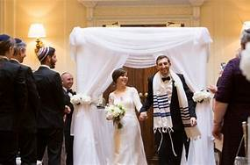
“Betroth: to promise "by one's truth." Men and women were betrothed when they were engaged to be married. This usually took place a year or more before marriage. From the time of betrothal the woman was regarded as the lawful wife of the man to whom she was betrothed (Deuteronomy 28:30 ; Judges 14:2 Judges 14:8 ; Matthew 1:18-21). The term is figuratively employed of the spiritual connection between God and his people (Hosea 2:19 Hosea 2:20). M.G. Easton M.A., D.D., Illustrated Bible Dictionary, Third Edition, published by Thomas Nelson, 1897. Public Domain, copy freely.

b) Presentation

Several days of joyous Festivities

c) Ceremony

Bride & Grooms verbal, Exchanging of their Vows

Then, the Final Supper, signifying the completion of the Ceremony

Marriage of the Lamb (7) continued-

The Church was betrothed, or given to Christ in Eternity Past.

Gen. 12:1-3, God to Abram
Gen. 22:15-18, God to Abraham
Gen. 26:1-5, God to Issac
Gen. 28:10-17, God to Jacob

What does all of this mean?

Since Scripture interprets Scripture, let us study what Paul says in Scripture.

Galatians 3:7-9. So, Paul’s interpretation, given by the inspiration of God (2 Timothy 3:16-17); is that the Gentiles, or the Church, were always in God’s Plan- from the very Beginning.

The Identity of the Bride and Bridegroom in the OT & NT

1. The Bridegroom in the Old Testament

a. Isaiah 62:5

ILL: ESVSBftn on Isa. 62:5

b. Hosea 2:19-20

ILL: “Hosea, in his great parable of the prodigal wife, surpassed only by a greater Teacher's parable of the Prodigal Son, uses betrothal as the symbol of Yahweh's pledge of His love and favor to penitent Israel (Hosea 2:19-20),” Orr, James, M.A., D.D. General Editor. "Entry for 'BETROTH,’” International Standard Bible Encyclopedia, (1915). These files are public domain.

ILL: ESVSBftn on Hos. 2:19

> What is the Bride’s “price”?

> How is the Bride’s “price” paid in this passage?

Therefore, the Bridegroom in the Old Testament was Yahweh and the Bride was Israel and the Non-Jewish proselytes who worshipped the God of the Jews.

2. The Bridegroom in the New Testament

a. Matthew 9:15; Mark 2:19

ILL: ESVSBftn. on Mt. 9:15

b. Revelation 21:9

The Church will be presented to Jesus at the Rapture.

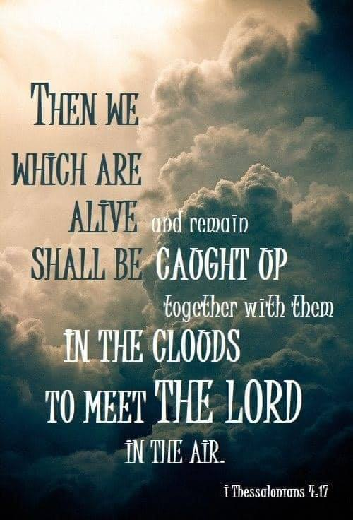
The Marriage Supper of the Bridegroom (Jesus) and the Bride (His Church) will occur at the establishment of the Millennium, also called the Millennial
Kingdom, which spans for 1,000 years.

Rev. 21:2

Righteous Acts (“deeds,” ESV) of the Saints (8)

Righteousness

1. Provided, or imputed (KJV) / (“counted,” ESV)

ILL: “he has covered me with the robe of righteousness,” Isa. 61:10

ILL: Romans 4:16-25

2. Produced, in daily practice

ILL: Romans 12:1-2

Those Who Are Called (“invited,” ESV) to the marriage supper of the Lamb (9)

MacArthur understands these “called” / “invited” as the Guests.

If so, who are these Guests who are participating in the marriage supper of the Bride (Church) and the Bridegroom (Christ, the Lamb)?

True Sayings of God (9)

Fell at His Feet (10)

Do Not Do That (10)

ILL: Rev. 22:8-9

The Testimony of Jesus is the Spirit of Prophecy (10) 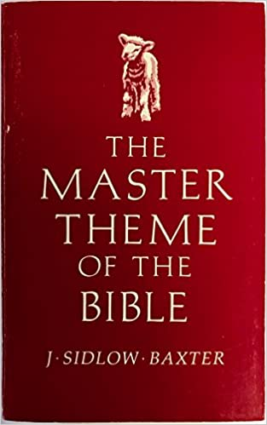

The Glorious Return of Jesus Christ
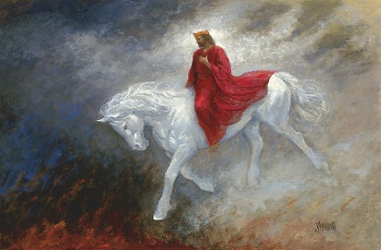

Verses 11 – 21

Heaven Opened (11)

Contrast Rapture & Return

Rapture:
Christ meets His own in the air (John 14:1-3; I Thessalonians 4:13-18)
Return:
Christ comes with His own
Rapture:
No Judgement
Return:
All Judgement
Rapture:
No meteorological or weather changes
Return:
Blackness- darkened Sun, Moon gone out, stars fallen, smoke- then lightening and blinding glory as Jesus comes.

In the Rapture, Christ took possession of His Church; in the Return, Christ will take possession of His Planet.

ILL: MacArthur summarizes: “The One who ascended to heaven and has been seated at the Father’s right hand (Hebrews 1:3, 13; 8:1-2; 10:11-14; and 12:1-2) will return to take back from the usurper and establish His Kingdom (5:1-10).”

White Horse (11)

Contrast the Farmer’s Colt (Zech. 9:9) with the General’s Horse

ILL: The Via Sacra (Latin: Sacra Via, "Sacred Street") was the main street of ancient Rome, leading from the top of the Capitoline Hill, through some of the most important religious sites of the Forum (where it is the widest street), to the Colosseum.

The road was part of the traditional route of the Roman Triumph that began on the outskirts of the city and proceeded through the Roman Forum. Later it was paved and during the reign of Nero it was lined with colonnades. The road provided the setting for many deeds and misdeeds of Rome's history, the solemn religious festivals, the magnificent triumphs of victorious generals, and the daily throng assembling in the Basilicas to chat, throw dice, engage in business, or secure justice. Many prostitutes lined the street as well, looking for potential customers. From the reign of Augustus, the Via Sacra played a role in the Apotheosis ceremony by which deceased Roman Emperors were formally deified

ILL: “Apotheosis (Greek: ἀποθέωσις, from ἀποθεόω / ἀποθεῶ, ''to deify''; also called divinization and deification from Latin: deificatio, lit. ''making divine'') is the glorification of a subject to divine levels and commonly, the treatment of a human being, any other living thing, or an abstract idea in the likeness of a deity. The term has meanings in theology, where it refers to a belief, and in art, where it refers to a genre. In theology, apotheosis refers to the idea that an individual has been raised to godlike stature. In art, the term refers to the treatment of any subject (a figure, group, locale, motif, convention or melody) in a particularly grand or exalted manner.”

Faithful and True (11)

In Righteosuness He Judges (11)

ILL: Rev. 20:11-15

Makes War (11)

ILL: Rev. 2:16

ILL: ESVSBftn on 19:11-21

His Eyes were like a Flame of Fire (12)

ILL: Rev. 1:4; 2:18

Christ sees through facades, penetrating people’s masks of secrecy.

A Name . . . No One Knew (12)

A Robe Dipped in Blood (13)
ILL: Purple Heart
“United States Military Decoration: The Purple Heart is a United States military
decoration awarded in the name of the President to those wounded or killed while
serving, on or after April 5, 1917, with the U.S. military.”

The Word (13)

ILL: John 1:1, 14

ILL: ESVSBftn 1:1-18 Prologue: The Incarnate Word

Armies in Heaven (14)

Who are in this Magnificent Group?

1. The Old Testament Saints,
e.g. Heb. 11 & The Hall of Faith. Sixteen Fathers & Mothers of The Faith

2. The New Testament Saints, i.e. The Church, also called the Bride of Jesus Christ, Rev. 19:7-8; 1 Thessalonians 4:13-18

3. The Seven-Year, Tribulation Saints, Rev. 7:13-14

4. God’s Holy, Angelic Family.
These are the unfallen angels, the messengers of God.

Sharp Sword (15)

ILL: Isaiah 11:4

ILL: Isaiah 49:2 and ESVSBftn on 49:2

Rod of Iron (15)

ILL: Psalm 2:9
ILL: Rev. 12:5

Winepress (15)

ILL: Rev. 14:17-20

ILL: ESVSBftn on Rev. 14:17-20

On His Thigh (16)

Supper of the Great God (17)

ILL: “Battle on the great day of God the Almighty,” Rev. 16:14

ILL: Matthew 24:2-28 and the ESVSBftn on that passage

ILL: Psalm 79:2

His Army (19)

ILL: Zechariah 14:5

“Then the LORD, my God will come, and all the holy ones with him.”

Beast was Captured, and . . . the False Prophet (20)

> The Beast is the Antichrist, the Political Leader who is empowered by the dragon (Satan) 13:1-4

> The False Prophet is the Antichrist’s Religious Co-Leader, who is empowered by the dragon (Satan), & is mandating the Mark of the Beast, 666 (13:16), on all human beings, 13:11-17

The Wickedness of Human Beings cannot successfully resist the
Sovereign Power of Almighty God.

Cast Alive (20)

> They are cast alive and remain alive in this dreadful and painful experience. This refutes those who teach annihilation.

> What is Annihilation?

“Annihilationism is the belief that unbelievers will not experience an eternity of suffering . . . , but will instead be “extinguished” after death. For many, annihilationism is an attractive belief because of the awfulness of the idea of people spending eternity in hell . . . [What] the Bible says about the destiny of the wicked reveals the fact that punishment in hell is eternal. A belief in annihilationism results from a misunderstanding of . . . the consequences of sin, the justice of God, [and] the nature of hell,” Https://www.gotquestions.org/annihilationism.html

Lake of Fire (20)

The Final & Eternal Place of Punishment for all in Rebellion Against their Creator-God. This includes Fallen, Wicked, Angelic Beings and
Unrepentant, Defiant Human Beings.

ILL: The phrase Lake of Fire is in the Bible 4 times, including:

Rev. 19:20
Rev. 20:10
Rev. 20:14
Rev. 20:15
Rev. 21:8
“the lake that burns with fire and sulphur”

Therefore, this Biblical Doctrine is anti-annihilationism

Fire . . . Brimstone (20)

ILL: MacArthur, p.92 & Note on 14:10

ILL: Bible Study No. 12, p. 6, on Rev. 14:10

Birds were Filled with Their Flesh (21)

ILL: ESVSBftn. on Rev. 19:21

Your Reflections & Responses?

