THE GREAT TRIBULATION
Destruction and Devastation, No. 16
Rev. 17:1 – 18:24
Part Two
***

Rev. 17-18 “reveals the dark destiny of the satanic kingdom.”

The Context: MacArthur, pp. 103 - 104

The Text: Rev. 18:1 – 24, Part Two

The Review: This brief outline is adapted from The ESV Study Bible, pp. 2486 -2487.

17:1 – 19:10 Babylon, the Prostitute

*** 17:1 - 15 Babylon’s Power and Luxury

*** 17:16 - 19:10 Babylon’s Fall Lamented and Celebrated

The Exposition:

Verses 1 – 3 “Another Angel . . . having Great Authority . . .” (1)

Earth was illuminated with his glory (1)

> The Planet is in darkness
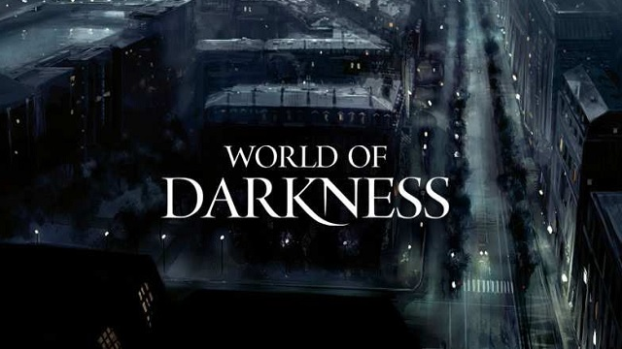
ILL: The Fifth Bowl, Rev. 16:10

ILL: The Ninth Plague on Egypt, which lasted 3 days
Exodus 10:21-29

> The Authoritative Angel lights up our Planet.

Babylon the Great is Fallen (2)

Compare Rev. 14:8 with Isaiah 21:9 & 21:9 ESVSBftn.

Wine . . . of her fornication (3)

> Religious Babylon (Rev. 17)

The unrepentant says: “No God, I’ll believe what I want.”

Compare & contrast with-

> Commercial Babylon (Rev. 18)

The unrepentant says: “No God, I don’t need you. I can get along fine without you.”

> The World is Self-centered, Power-driven & Pleasure-crazed.

Kings . . . Merchants (3)

Verses 4 – 20 “Another Voice from Heaven . . .” (4).

Come out of her, my people (4)

Separate from the Arrogant, Self-sufficient, & Self-indulgent.

ILL: Romans 12:1-2
Remembered (5)

> God chooses to remember the wickedness of the unrepentant.

> God chooses NOT to remember the forgiven sins of the repentant.

> Walking down the steps of Divine Forgiveness:
Psalm 97:10
Psalm 103:12
Isaiah 38:17;
Isaiah 43:25
Jeremiah 31:4
Micah 7:14
John 3:16-18
I John 1:9

Repay (6 – 7)

ILL: Romans 12:17-19

Double (6)

ILL: Jeremiah 16:18

Cup (6)

Am no Widow (7) and “I sit as a Queen”

Self-glorification & the “Delusion of Affluent Security”

ILL: ESVSBftn. on Rev. 18:7-8.

Her Plagues (8)

ILL: Like the 10 plagues on Egypt in Exodus, the Babylonian plagues will be upon the anti-God belief system and the literal City of Babylon.

In one day (8)

ILL: Isaiah 47:7-9, “in a moment, in one day . . . “ (9)

Kings (9) “will weep and wail . . .” (9)

The death of their Capital City will signal the doom of the Antichrist’s Kingdom & the eventual loss of their power, prestige & prosperity.

Weep and lament for her (9 - 11)

Purple (12)

ILL: Acts 16:14 – 15

Lydia is a God-fearing, wealthy woman who owned her own business in the city of the 4th Church in Rev. 2-3, Thyatira. Lydia believes, and is baptized, and offers hospitality to Paul, Silas, and Timothy (vss. 1-4).

“A distinctive mark of the Caesars was their purple robes.”

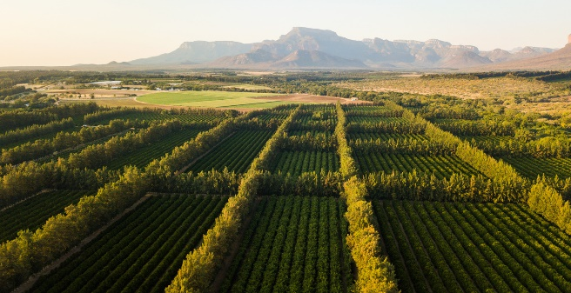
https://www.soleilsitrus.co.za/our-farms/

Citron wood (12)

Modern citrus trees and wood today. The Soleil Sitrus Group have farms and packhouses in multiple provinces in South Africa.”

Marble (12)

Fragrant Oil (13)

Expensive Ointment or Perfume

ILL: Matthew 26:6-13

Frankincense (13)

“Frankincense (Arabic: al-luban)) is an aromatic resin used in incense and perfumes. Frankincense is obtained from trees of the Boswellia family, which mainly grow in Somalia [Africa] and Oman [Saudi Arabia], (see map below).

Frankincense oil has been called the king of essential oils. Frankincense oil has become particularly popular in the past few years as it is used in skin care products and is particularly good for aging skin. It helps with respiratory ailments and relieves nervous tension and stress related disorders. It is also a popular oil for meditation,” https://arabiconline.eu/frankincense-in-the-arab-world/

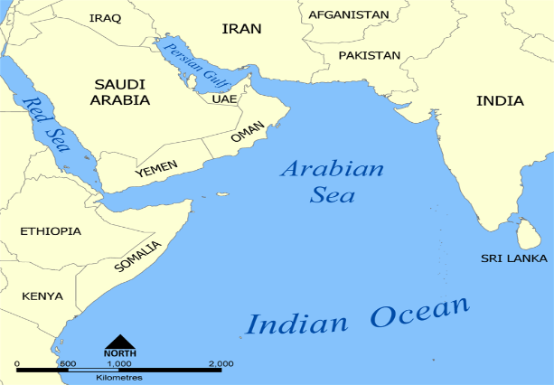

ILL: Song of Solomon 3:6

ILL: Mathew 2:11

Bodies and Souls of Men (13 - 16)

The horrific Slave Trade will reappear in the Antichrist’s godless Empire.

ILL: Emancipation Day is a holiday in Washington DC to mark the anniversary of the signing of the Compensated Emancipation Act, which president Abraham Lincoln signed on April 16, 1862. It is annually held on April 16, https://www.timeanddate.com/holidays/us/emancipation-day-dc

Shipmaster (17 - 18)

ILL: “A record number of cargo ships [61] off the California coast shows a crack in the supply chain.” By Gregory Schmidt, Pub. Sept. 23, 2021, Updated Oct. 18, 2021, The New York Times.

Threw Dust on their Heads (19)

ILL: I Samuel 4:12 and the ESVSBftn. for 4:12

In one hour (19)

This phrase is repeated 3 times, in 18:10, 17, and 19. It punctuates brevity, not 60
minutes or 3,600 seconds.

God has Avenged You on Her (20)

ILL: ESVSBftn. on 18:20

Verses 21 – 24 “A Mighty Angel took . . .” (21).

Great Millstone (21)

ILL: Jeremiah 51:63 Jeremiah’s final, symbolic act.

ILL: ESVSBftn. on Rev. 18:21

Shall not be heard (22 – 23)

The music stops!

Blood of Prophets and Saints (24).

Unspeakable, unimaginable atrocities by the hands of the Antichrist & his violent, army of murderers. Historically, think back to the horrific, days of slaughter. It will be like that, or worse.

But God will win. Yahweh will avenge His People. The Authority of Christ will prevail, Rev. 19:2.

Truth for Today:

MacArthur, p. 113.

Your Reflections & Responses?

