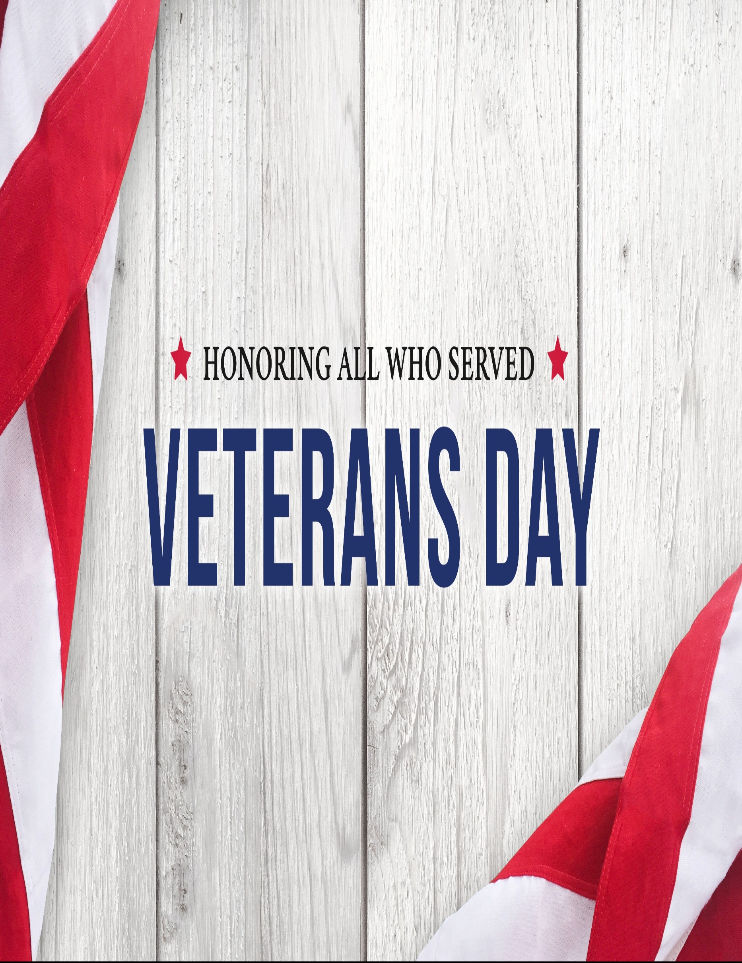

Enola Church of God’s

2025 Annual Breakfast

Honoring Veterans

and Their Families.

Saturday, November 15, 2025

9:00-11:00 AM
Please RSVP by 11/09/2025 by signing up at sign-up central or by calling Crystal at (717)5571842

Enola Church of God

9 Sherwood Dr.

Enola, PA 17025

