ALL THINGS NEW
Paradise Regained, No. 20
Rev. 22:1 – 21; Part Two

The Context: MacArthur, p. 127 - 128

Keys to the Text:

New Jerusalem, MacArthur, p. 128

The Bride, the Wife of the Lamb, MacArthur, p. 128
Understanding the Bride better:

OLD TESTAMENT Background: As God referred to Himself as the “husband”
of Israel, (Isaiah 54:4-5), so Jesus pictures himself here as a Bridegroom (Matt. 9:14-15). John, the Baptizer, identified Jesus as the Bridegroom (John 3:29).
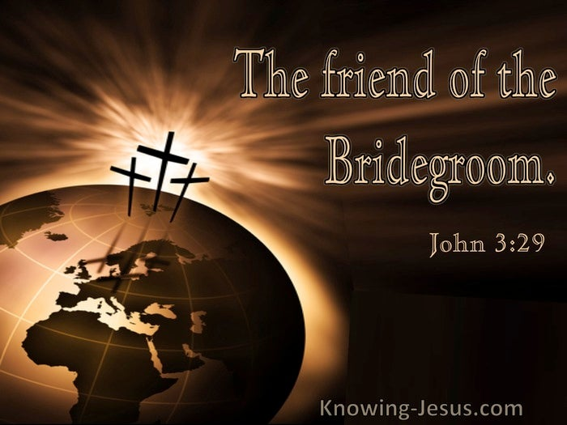
Understanding the Bride better:

1. Matthew 25:1 – 13 The Parable of the Ten Virgins (Bridemaids)

See handout on:

ILL: 25:1 ESVSBftn; ILL: 25:3-4 ESVSBftn; ILL: 25:9-10 ESVSBftn;

ILL: 25:11-12 ESVSBftn; ILL: 25:13 ESVSBftn

2. Ephesians 5:25-32 The “Mystery,” (32)

See handout on:

ILL: 5:25 ESVSBftn; ILL: 5:26-27 ESVSBftn; ILL: 5:28-30 ESVSBftn

ILL: 5:31 ESVSBftn; ILL: 5:32 ESVSBftn

The Text: Rev. 22:1 – 21, Part Two

The Exposition:

River . . . of life / river of the water of life (1)

ILL: Rev. 21:6.

It is likely that this water is symbolic and points to the on-going and continuous flow of eternal life and blessing.

Tree of life (2)
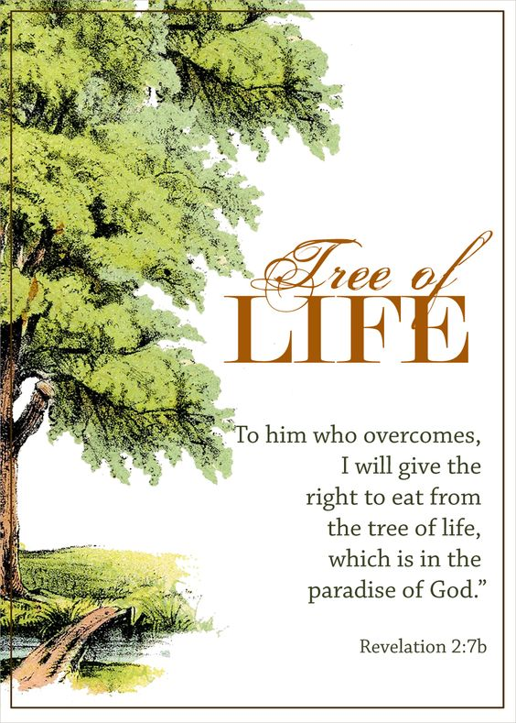

ILL: ESVSBftn on Rev. 22:1-2
No more curse / No longer will there be anything accursed (3)

ILL: Genesis 3:16-19

Curse cancelled out in the New Heaven and New Earth.

See His face (4)

What was prohibited is here promised

ILL: Exodus 33:20-23

His name (4) 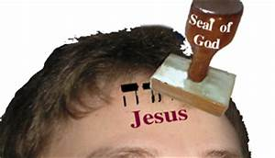

God’s Ownership

ILL: Rev. 3:11-12; 7:2-4; 14:1

They shall reign (5)

ILL: Rev. 5:10

ILL: 2 Peter 3:13

ILL: OLD TESTAMENT Background

1. Isaiah 65:17

2. Isaiah 66:22

His Servants (6)

The practice of the early church was for them to receive the Word orally by a traveling Messenger who would read the Word before going to the next town to read it. Who are “His Servants” the angel was sent to show the things, which must shortly take place?

1. Rev. 1:10-11 Thus, the 1st. Century Believers of the 7- Churches
(Rev. 2-3)

2. Rev. 1:3 Therefore, the Believers since who:
a) “read,” b) “hear,” and c) keep” “what is written in it.”

Things which must shortly take place (6)

I Am Coming Quickly / Soon (7, 12 and 20)

ILL: Rev. 3:11

ILL: Imminency in ISRAEL MY GLORY

ISRAEL MY GLORY
February / March 1996 Renald Showers
The Imminency of Christ’s Return

“The expression the imminency of Christ’s return means that Christ could return at any moment. Nothing else has to happen before His return.”

“The Westminster Confession, xxxiii, 3 (written by the Puritans of England during the 1600s), declared that men should “shake off all carnal security and be always watchful, because they know not at what hour the Lord will come.”

“In his book The Imminent Appearing of Christ, after an entire section dealing with some of the Bible passages upon which the imminency of Christ’s return has been based historically, Payne made the following comment about the concept of Christ‘s imminent return: “The preceding section has validated a considerable group of passages that do demonstrate its legitimacy. In fact, no natural reading of Scripture would produce any other conclusion.” Payne also stated, “Belief in the imminency of the return of Jesus was the uniform hope of the early church.” Concerning early church believers, he said, “They were waiting, eagerly awaiting, His imminent appearing,” (J. Barton Payne).
“(1936-2019) Dr. Renald Showers was an author, trusted theologian, and Bible teacher for the Friends of Israel Gospel Ministry.”

Heard and Saw (8)

ILL: Rev. 1:1, 4, 9

Do not seal the words (10)

ILL: Unlike Daniel. Daniel 9:24; 12:4, 9

The Time is at hand (10)

ILL: Why? Because Christ won the victory at His Cross! I Corinthians 15:51-57

According to his work (12)

Blessed are those who do His commandments / wash their robes [ESV] (13 - 14)

There is a variance, or difference in the primary Greek manuscripts on this verse. I am uncertain which was written in the original text. However, the differences are not a contradiction because both are biblically true. Therefore, it is the opinion of this writer that the variance is doctrinally insignificant.

ILL: Rev. 1:3

ILL: Hebrews 9:11-14

ILL: I Peter 1:13-19

Dogs (15)

Humans Bankrupt in Character and Morals

ILL: Isaiah 56:10-11

Israel’s Irresponsible Leaders are described as 1) blind, 2) ignorant,
3) silent, 4) lazy, 5) and selfish, “turned to their own way,” (11).

Application: What is our calling today? The opposite!

ILL: Deuteronomy 23:17-18

Money from female cult prostitution and money from male cult prostitution was prohibited in God’s house. Prostitutes were likened to dogs.

ILL: I Kings 14:23-24

>> ESVSBftn. on 14:24

ILL: Pagan Worship of Baal

“Asherah was worshiped in various ways, including through ritual sex. Although she was believed to be Baal's mother, she was also his mistress. Pagans practiced "sympathetic magic," that is, they believed they could influence the gods' actions by performing the behavior they wished the gods to demonstrate. Believing the sexual union of Baal and Asherah produced fertility, their worshipers engaged in immoral sex to cause the gods to join together, ensuring good harvests. This practice became the basis for religious prostitution (1 Kings 14:23-24). The priest or a male member of the community represented Baal. The priestess or a female members of the community represented Asherah. In this way, God's incredible gift of sexuality was perverted to the most obscene public prostitution. No wonder God's anger burned against his people and their leaders,” Ray Vander Laan, (https://www.thattheworldmayknow.com/fertility-cults-of-canaan).

Application: Almighty God’s biblical prescription for sexuality is marriage.

Marriage = 1 man + 1 woman for 1 lifetime.

The churches (16)

The Root and Offspring of David (16)
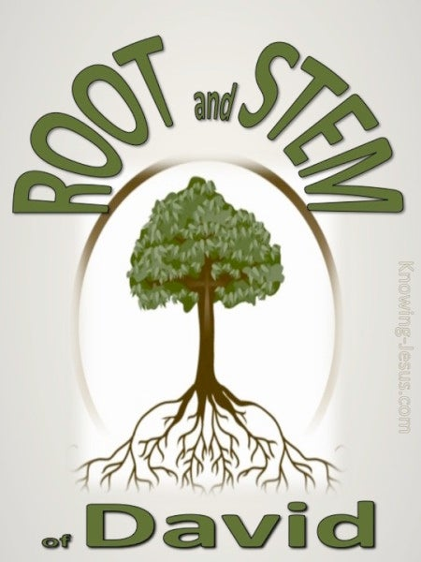

ILL: 2 Timothy 2:8-13

“Remember Jesus Christ”

> Risen
> Offspring of David
> Faithful
For He cannot deny Himself.

ILL: Matthew 1:1

“The book of the genealogy of Jesus Christ, the son of David, the son of Abraham.”

Bright and Morning Star (16)
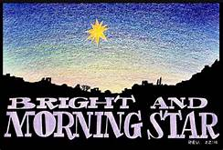
“Come” (17)

Let him (17)

Surely I am coming quickly (20)

ILL: 2 Peter 3:11-18

Living Effectively in View of the Lord’s Return

“What sort of people ought you to be?” (11a)

1. We ought to live in holiness and godliness (11b).

2. Motivated by the soon coming of Jesus, our Savior (12).

3. Depending on the Promise of the new heavens & new earth (13).

4. Actively growing & living doctrinally & morally pure (14).

5. Avoiding spiritual ignorance & instability (15-16).

6. Firmly fastening our moral anchor in the inspired
Word of God (17).

7. Growing more and more like our Lord Jesus Christ (18).

Application: These 7 biblical answers to the biblical question, “What sort of people ought you to be?” serve as a spiritual yardstick that we may use to measure our own spirituality.

Your Reflections & Responses?

