THE GREAT TRIBULATION
Victorious Voices, No. 14
Rev. 14:1 – 16:21
Part Three

Reflecting on the Text: MacArthur, p. 101b

“One of the themes that links Revelation 14-16 together is expressed by the word voice,
which is used eleven times. In the events recorded, God speaks to:

[1] His people or
[2] to the lost world, or
[3] His people and angels speak out in praise of the Lord or
[4] in warning to the world.

As the world moves into the last half of the Tribulation, heaven is not silent, [emphasis mine].” Warren W. Wiersbe, BE VICTORIOUS (Colorado Springs: David C. Cook, 1985), 137, op cit. by John MacArthur, REVELATION.

The Text: Rev. 16:1 – 21, Part Three

The Unrestrained & Comprehensive Expression
of God’s Wrath

Bowl Area Affected Reference Result

Bowl 1 Earth 16:2 Sores on the Beast’s Worshippers
Bowl 2 Sea 16:3 Blood and Death
Bowl 3 Rivers and Springs 16:4-7 Blood to Drink
Bowl 4 Sun 16:8-9 Burning Heat
Bowl 5 Beast’s Throne 16:10-11 Palpable Darkness
Bowl 6 Euphrates River 16:12-16 Gathering for the Battle
Bowl 7 Air 16:17-21 Earthquake shattering the great city

The ESV Study Bible, (Crossway: Wheaton, 2008, www.ESV.org), p. 2485.

The Exposition:

Verses 1-3

First . . . bowl . . . a foul and loathsome sore (1-2)

Job 2:7

ILL: “One cannot fully understand Job’s conversations throughout the book
without considering the extraordinary physical distress he endured in a day
without medicine or pain relief,” The MacArthur Study Bible,” New King James Version, (Word: Nashville, 1997).

ILL: Luke 16:21 “covered with sores,” (ESV).

Mark of the Beast (2)

> The Fact: 13:16
> The Affect: 14:9-11
“Only worshippers of the Antichrist will ____ ____________.

Second . . . bowl . . . every living creature in the sea died (3)

Exodus 7:14-24
The Egyptian Nile River becomes blood in the first plague against Egypt.

ILL: Dead Sea Pool Turns Blood Red Puzzling Experts
“A pool of water located close to the Dead Sea in the biblical region of Moab – modern day Jordan – has mysteriously turned blood red. Water from the red
lagoon just inside the Jordanian border is being sampled by workers from
Jordan’s Ministry of Water and Irrigation to determine the cause of the unsettling
phenomenon which is as yet unexplained,”
Posted on 09/14/2021 by EraOfLight, https://eraoflight.com/2021/09/14/dead-sea-pool-turns-blood-red-puzzling-experts/

Application: What is God doing? I believe he is providing the World with an
Object Lesson. For example, in the 70s, I was explaining the Rapture to an
Elementary School age Sunday School class, using a magnet. I ______________ .

Verses 4-7

Third . . . bowl . . . rivers and springs of water (4)

Who is and who was and who is to be (5)

Notice the differences in translations.

NKJV:Who is and who was and who is to be
KJV: Which art, and wast, and shalt be
ESV: Who is and who was / NASB: Who is and who was

The theology in the phrase expresses the Eternality of God.

ILL: 1:4, 8; 4:8; 11:17

Give them blood to drink (6)

For it is their just due (6)

“God’s judgment is fair and proper.”

Exodus 21:23-25

“Eye for eye,” The Laws about Restitution for Judges

What does this mean? See ESVSBftn. for 21:23-25.

Our God is a Fair, Impartial, and Just God.

Altar (7)

Personified Alter verbally reinforces the justice of God’s judgments

Ill: Def. of personify: “to attribute human nature or character to (an
inanimate object or an abstraction), as in speech or writing,”
https://www.dictionary.com/browse/personified

ILL: Example of personification: Proverbs 8:1-4

Biblical Theology: The Theology of Divine Judgment

α. Genesis 18:25
β. Psalm 51:4 and ESVSBftn on 51:4
γ. Romans 3:4 and LXX, the Septuagint
δ. Revelation 19:1-2

Our God justly, impartially, and fairly judges His Creation. He is right and this is the right thing to do.
Verses 8-9 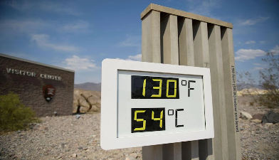

Fourth . . . bowl . . . scorch . . . with fire (8)

ILL: “Summers can be hot in Death Valley, California. In fact, it is likely the hottest place on Earth—ever. Especially on Sunday, August 16 and—again—on June 17, 2021. The mercury spiked to a sweltering 130 degrees Fahrenheit in the national park, drawing crowds of tourists who flocked to take pictures with the park’s digital thermometer,” https://www.yahoo.com/entertainment/hottest-place-earth-140000333.html

They did not repent (9)

This is difficult to imagine. Why are humans so rebellious against their Creator?

Rev. 2:5
Rev. 9:20
Rev. 16:9
Rev. 16:11
Rev. 16:21
Romans 1:28-32

Verses 10-11

Throne of the Beast (10)

The Antichrist’s Kingdom

Full of Darkness (10)

Global Darkness

Gnawed their tongues (10)

Self-inflicted pain as pain relief

Blasphemed the God of heaven (11)

You would think they would surrender to God’s sovereignty; saying, you win, you’re right, we will trust you fully.

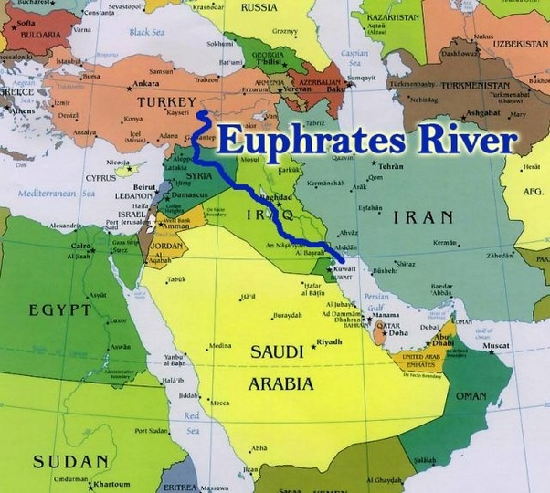
Their sores (11)

Verses 12-14

Euphrates (12)

“The Euphrates River is the western and southernmost river of the area, the other being the Tigris River, which runs to the north and east. Both begin in eastern Turkey, their sources less than 50 miles apart from one another. They run through modern-day Syria and Iraq, joining just before the Persian Gulf. The Middle East lies between the Mediterranean Sea and the Persian Gulf, making it a center for trade and civilization,” (https://study.com/learn/lesson/where-is-the-euphrates-river-map.html).

The Kings from the East (12)

The Coming Armies of the Antichrist’s World System to the Battle of Armageddon in 14 and 16.

Three unclean spirits (13)

Matthew 12:43
Mark 1:23
Luke 8:29
Therefore, an “unclean spirit” is a ____________.

Like frogs (13)

The Principle: Leviticus 10:11

The Practice: Leviticus 11:10-11

ILL: ESVSBftn. 11:9-12

ILL: Persian Mythology-

Devilish Creatures Which Had the Power to Detect Poison:
“In medieval Europe, toads were thought of as devilish creatures whose evil blood was used as a potent poison and whose body parts were associated with strange supernatural powers.

Some of these anti-amphibian views were first created by writers in
Classical Greece and Rome, whose opinions held great sway in medieval
Europe. Pliny the Elder claimed, “a toad's presence will silence a room
full of people,” (https://www.ancient-origins.net/myths-legends-europe/ambiguous-amphibian- everchanging-frog-symbol-world-myth-009560).

The dragon . . . the beast . . . the false prophet (13)

The “Unholy Trinity.”

ILL: Rev. 13 diagram [Class Exercise drawing the “unholy trinity.”]

Signs (14)

13:12-15

Counterfeit resurrection, fire from heaven, a religious object that “speaks.”

19:20

Successfully deceived billions and billions of the Earth’s inhabitants.
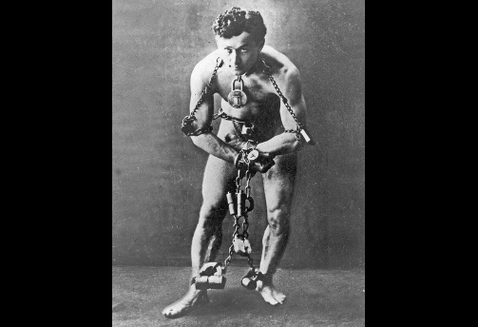
Mark 13:22

ILL: Harry Houdini, (1899). In this 1899 photo, Harry Houdini famously
poses wrapped in chains and locks before performing a death-defying
escape in front of a large crowd, (AP, Associated Press).”

The Magic of the Great Illusionist, Harry Houdini, will seem amateurish
compared to these devilish, demonic signs.

Kings of the Earth (14)

א. Psalm 2:1-3

ב. Joel 3:2-3, and ESVSBftn. 3:1-21; 3:1; 3:2; 3:3

ג. Wickedness will be Judged Severely
Deportation and exile
Slavery
Sex Trafficking (traded a boy, sold a girl)

ד. Zechariah 14:1-3

ILL: In ESV, the phrases A day (1); On that day (Vss. 4, 6, 8, 9, 14, 20) occur 7 times. This is an appointed time, determined by God, to complete a specific part of His unfolding Plan of Redemption on our Planet Earth.

The [Future] Battle of that Great Day of God Almighty (14)

Joel 2:11

Jeremiah 33:15

2 Thessalonians 1:5-10

2 Peter 3:10

Verse 15

Watches, and keeps his garments (15)

I John 2:28

> Confident in and when He comes
> Continuous Expectation & Spiritual Readiness
> Avoiding procrastination & Serving Jesus Christ Wholeheartedly

Verse 16 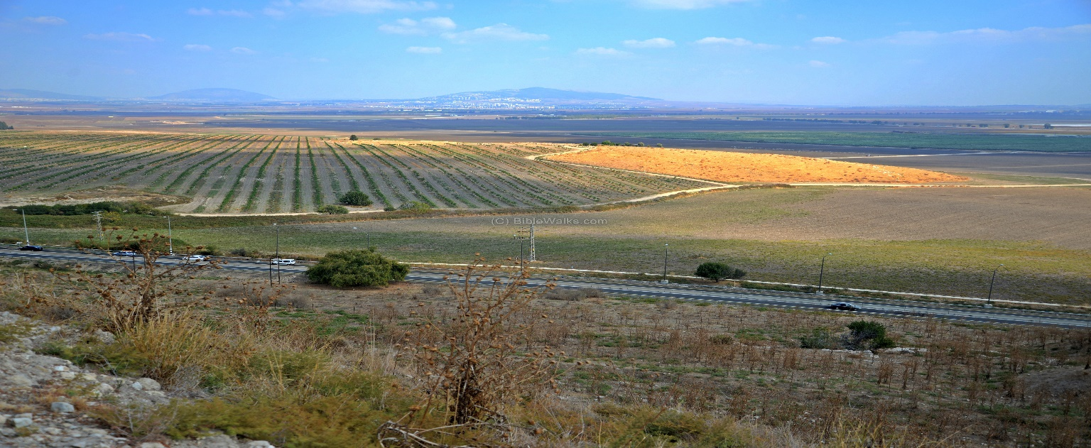

Armageddon (Hebrew, Har-megiddo, 16), or Mount Meggido
Tel Meggido, www.Biblewalks.com

“Megiddo, named in the Book of Revelation as the setting for a future battle between the forces of good and evil, is for archaeologists perhaps the most important site in Israel dating from biblical times. Its much-excavated tel, a mound rising 60 metres [about 197 feet] above its surroundings, has revealed the remains of at least 20 cities built one on top of the other.

The 6-hectare site [Hectare is: “a unit of surface, or land, . . . equivalent to 2.471 acres,” thus about 15 acres (https://www.dictionary.com/browse/hectare)], has yielded temples, lavish palaces, massive fortifications, private houses, a grain silo and an elaborately-engineered water system. Megiddo is 35 kilometres [about 22 miles] southeast of Haifa, at the southern end of the fertile Jezreel Valley. Destroyed and rebuilt many times during its turbulent history, it was occupied almost continuously from around 6000 BC until about 500 years before Jesus Christ was born.

From its strategic position, overlooking the key pass through the Carmel Mountains, it dominated the crossroads of ancient trade and military routes that linked Egypt with Mesopotamia and Asia Minor.

Armies of all the great generals who campaigned in the Middle East tramped across the plain of Jezreel, from the Egyptian pharaoh Thutmose III to General Edmund Allenby, including Alexander the Great and Napoleon. As Thutmose III claimed in the 15th century BC, “Capturing Megiddo is as good as capturing 1000 cities.”

In 2005 the remains of an ancient Christian prayer hall were uncovered in the grounds of a nearby prison. Dated to the middle of the 3rd century, this may be the oldest church discovered in Israel. A mosaic inscription with the words “God Jesus Christ” may be the earliest ever found that mentions Jesus Christ,” https://www.seetheholyland.net/megiddo/ Cited 09/29/21).

Verses 17-21

Seventh . . . bowl . . . “It is done,” (17)

ILL: John 19:30, “It is finished.”

The Great City (19) 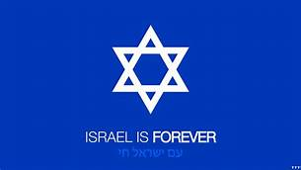 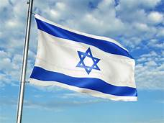

Jerusalem- Preserved under Yahweh’s Providence

Zechariah 14:1-8

Cities of the Nations (19)

World’s cities- Plundered under Yahweh’s Justice

ILL: Chart: Oracles Against Other Nations in the Prophets, ESVSB, p. 1264

Babylon (19)

The Capital of the Antichrist’s Kingdom

Isaiah 13 (We’ll read the entire chapter)

Every island fled . . . mountains . . . not found (20)

Earth’s topography changed by a massive earthquake

A talent (21)

About 75 pounds

ILL: “I was not disobedient to the heavenly vision, but declared first to those in
Damascus, then in Jerusalem and throughout all the region of Judea, and also to
the Gentiles, that they should repent and turn to God, performing deeds in keeping
with their repentance,” (Acts 5:19-20, ESV).

Your Reflections & Responses?

