THE GREAT TRIBULATION
The Terrible Triumvirate, No. 11
Rev. 12:1 – 13:18
Part Two

Deeper Definitions:
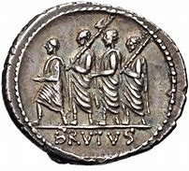

What is a Triumvirate? Consider the Roman Republic, 509 BC – 27 BC

“The first triumvirate of the Roman Republic, which consisted of Julius Caesar, Pompey, and Crassus, was simply an alliance or partnership, not a formal institution of the government. The alliance didn't last long, however, and Caesar eventually emerged with total power. This led to his assassination, [44 BC] after which a second triumvirate took over, with Octavian, Mark Antony, and Lepidus dividing the Roman world among themselves. But these triumvirs also soon turned on one another, with Octavian alone taking power; in time he would become Rome's first emperor,” (https://www.merriam-webster.com/dictionary/triumvirate#learn-more).

A triumvirate is- “a body of triumvirs; . . . a group or association of three” [rulers], (Op cit.).

Who are the Triumvirs in the Terrible Triumvirate in the book of Revelation?

These heinous triumvirs are Satan (the dragon), Antichrist (the first beast) and the False Prophet (the second beast). Together, they are counterfeits of the biblical Trinity, or The Unholy Trinity.

The Text: Rev. 13:1 – 18, Part Two

Verses 1 – 10

The First Beast: from the Sea
The Antichrist

Then I (He) stood (1)

Refers back to 12:17. Satan is on the land (sand of the sea) & the beast (Antichrist) is rising out of the sea. This is their dramatization of Power & Position on our Planet.

A beast (1)

A demon-possessed, Political World Leader, The Antichrist, leading the last World
Empire. He isn’t just an antichrist, which there have been many in history, but he is
The Antichrist. He is the last one, the final one, the “man of lawlessness,” (“the son of
destruction,” “the lawless one”), (2 Thess. 2:1-12).

He is a Delegate or Representative of the “god of this world,” (2 Cor. 4:4), the Fallen
Angel, Satan (Gen. 3:15).

ILL: Many antichrists,
like the modern Christ haters.
1 John 2:18
1 John 2:22
2 John 1:7

Spirit of the antichrist,
like the modern spirit of rebellion.
1 John 4:3

Rising up out of the sea (1)

Seven heads and ten horns (1)

The Symbolic Language

α. Heads, seven
β. Horns, ten
γ. Crowns / diadems, ten

Daniel 2:31-45

Blasphemous name (1)

Emperors and Angels saying: I AM GOD

Leopard (2a.)

A Metaphor for Ancient ___________ Daniel 7:1-6

Bear (2b.)

A Metaphor for Ancient _________________ Daniel 7:5
Lion (2c.)

A Metaphor for Ancient _______________ Daniel 7:4

His deadly wound was healed (3)

MacArthur says this is a “fake death and resurrection.” It is interesting that this fake
death is one of the ways atheists try to explain away the bodily resurrection of our Lord
using the Swoon Theory.

“The Swoon Theory suggests that the cool, damp air of the tomb somehow revived Jesus after three days and He decided to exit. Despite not having access to desperately needed medical care and nourishment, Jesus supposedly managed to unwrap His dressings and then, in the total darkness of the tomb, locate and roll away the mammoth stone sealing the tomb entrance. And then, still unnoticed by the guards, Jesus supposedly walked away, on feet punctured by the cross nails, to rejoin His disciples.

The most significant problem with this theory is that it greatly underestimates the severity of Jesus’ wounds. Historical sources confirm that Jesus was horribly tortured—and confirmed dead by several sources before He was removed from the cross,” * Josh McDowell Ministry is a Cru ministry (the U.S. division of Campus Crusade for Christ International), https://www.josh.org/about-us/joshs-bio/

Satan attempts to duplicate the death and resurrection of Jesus Christ.

World marveled (3)

Rev. 17:8

Was given (5)

The Antichrist is limited by the Sovereign, Lord God.

Forty-two months (5)

The Abomination of Desolation (Matt. 24:15) initiates the second half of the Tribulation. These 1260 days are referred to in Scripture as the “time of Jacob’s Trouble” (Jer. 30:7)
and Daniel’s 70th week (Dan. 7:25; 9:24-27).

His name (6)

His tabernacle (6)

Those who dwell in heaven (6)

The Holy, Heavenly Host (Angels, Cherub / cherubim & Seraph / seraphim),
Glorified Children of God, and the Triune God, (Father, Son, and the Holy Spirit).

ILL: In the KJV, Cherub is used 69 times and Seraph is used twice. Of these 71 times, only once is cherub used in the NT- in Hebrews 9:5.

Make war with the Saints (7)

The Antichrist’s delegated and temporary authority is deadly.

Lamb slain (8)

“For our sake he made him to be sin who knew no sin, so that in him we might become
the righteousness of God,” (2 Corinthians 5:21, ESV).

From the foundation of the world (8)

Act 2:22-36. Notice “this Jesus (23) and “This Jesus” (32) in ESV.

Verses 11-18

The Second Beast: from the land
The False Prophet

Another beast (11)

The final, and last False Prophet. Just as we learned that there are many antichrists in the
world, there is only one, final, Antichrist. Likewise, there are many false prophets in the
world, but there is only one, final, False Prophet.

ILL: 16:13; 19:20; and 20:10

Out of the earth (11)

Two horns like a lamb (11)

Pointing to rank & power, as a submissive, to the Antichrist; the Lead Demon.

Like a lamb (11)

False Lamb, masquerading as the True Lamb; the Lamb of God.
This counterfeit will woo the world & appear genuine to the world’s blind eyes.

Spoke like a dragon (11)

John 8:44
Exercises all authority of the first beast (12)

Both Beasts, the Antichrist & the False Prophet are empowered from the same source, the “Father of lies,” (John 8:44, ESV).

Causes . . . to worship (12)

Godless World Religion

Whose deadly wound was healed (12) 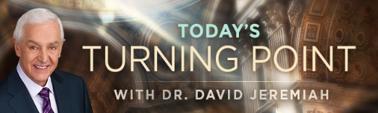

“The four Gospels record three instances of Jesus bringing a deceased person back to life. The daughter of Jairus, a Jewish leader, died and was raised from the dead (Luke 8:41-42, 49-56). So was the son of a widow in the village of Nain (Luke 7:11-15). The best known of the three was the raising of Lazarus, who had been dead for four days (John 11:1-44)” (Wednesday, September 8, 2021).

Great signs (13)

Exodus 7:11 and ESVSBftn. on 7:11-12.

Fire came down from heaven (13)

Counterfeit, Pyrotechnic Signs.

Make an image (14)

Self-deification, like many human Emperors throughout history.

ILL: “…in no part of the world was there such fervent and sincere loyalty to the emperors as in Asia. Augustus had been a saviour to the Asian peoples, and they deified him as the Saviour of mankind, and worshiped him with the most whole-hearted devotion as the ‘present deity’.” W. Ramsay, The Letters to the Seven Churches (New York: Hodder & Stoughton, 1909) 115. Cited 09/12/21 at https://readingacts.com/2010/04/02/the-roman-cult-of-emperor-worship/

Speak (15)

Appearance of Life & Appearance of Speech

ILL: Psalm 135:15:19

ILL: Habakkuk 2:19, Deaf and Dumb idols.

Cause . . . to be killed (15)

A mark (16)

“In the Roman Empire, this was a normal identifying symbol, or brand that slaves and Soldiers bore on their bodies.”

ILL: Like gang tattoos 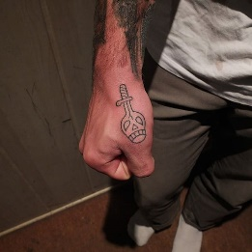 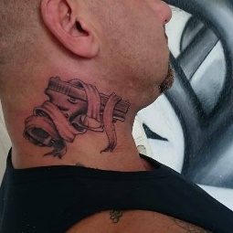

ILL: ESVSBftn. Rev. 13:16-17

Buy or sell (17)

Number of his name (17)

ILL: ESVSBftn. Rev. 13:18

His number is (18)

666 = Possibly “creature deficiency” ?

We only KNOW with certainty what God communicates to us in His Written Word. Therefore, let’s fully believe the revelation God provided to us and avoid speculating
about what He did not clearly spell out for us.

Amen.

Reflections & Responses?

