THE GREAT TRIBULATION
Destruction and Devastation, No. 15
Rev. 17:1 – 18:24
Part One

The Context: MacArthur, p. 103

Rev. 17-18 “reveals the dark destiny of the satanic kingdom.”

Keys to the Text: 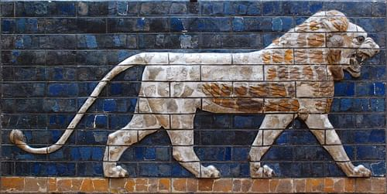
Lion of Babylon: Ishtar Gate

“Babylon,” in Genesis (Actual Ancient City)

“Detail of a lion found along the processional way from Ishtar Gate into the city of Babylon. The Ishtar Gate was constructed around 575 BC by King Nebuchadnezzar II of Babylon, made of fired bricks and decorated with animals made in glazed bricks,” https://www.worldhistory.org/image/724/lion-of-babylon-ishtar-gate/

“Babylon is the most famous city from ancient Mesopotamia whose ruins lie in modern-day Iraq
59 miles (94 kilometres) southwest of Baghdad. The name is thought to derive from bav-il or bav-ilim which, in the Akkadian language of the time, meant 'Gate of God' or 'Gate of the Gods' and 'Babylon' coming from Greek,” https://www.worldhistory.org/babylon/

The Ancient City of Babylon: History of the Babylonian Empire, video (11:03).
https://youtu.be/q-ZGsqwXsNM

Genesis 11:1-9

ILL: ESVSBftn 11:1-9

ILL: ESVSBftn 11:2-4

A Chart of Genesis 11:4, ESV Study Bible, p. 69

Action Purpose Desire

They built a city in order not to be dispersed [Self-]
over the face of the earth Security

They built a Tower in order to make a name for themselves [Self-]
With its top in the heavens Praise

“Babylon the Great,” in Revelation (A godless System)

“The entire worldwide political, economic, and religious kingdom of the Antichrist.”
John MacArthur

Rev. 16:17-19

The Text: Rev. 17:1 – 18, Part One

The Exposition:

Verses 1 – 15
Babylon’s Power and Luxury

Seven angels (1)

Great Harlot (1)

ILL: 14:8 and ESVSBftn on 14:8

Example: Cities engulfed in spiritual harlotry

1. Nineveh, the Capital of the Assyrian Empire
Nahum 3:1-4

2. Tyre, the “merchant of the nations,” (map, p. 1253)
Isaiah 23:17

ILL: ESVSBftn. 23:1-18

ILL: ESVSBftn. 23:1-14

3. Jerusalem, the Capital of Israel and “City of David,”

Isaiah 1:21 and ESVSBftn. 1:21

Sits on many waters (1)

Global Power.

Kings . . . committed fornication (2)

Global Faithfulness to the False Christ, the Counterfeit

Wine of her fornication (2)

Clarification: “The imagery does not describe actual wine and sexual sin, but pictures the world’s people being swept up into the intoxication [or drunkenness] and sin of a false system of religion,” (John MacArthur, p. 104).

In the Spirit (3)

ILL: 1:10; 4:2; 21:10

A Woman (3)

She is the “great harlot” in verse 1. These two are symbolic of Babylon.

Scarlet Beast (3)

> The color scarlet is ________________________________________________.

> The Scarlet Beast is the same beast of Rev. 13:1, 4; 14:9; 16:10

ILL: ESVSBftn. 13:1-2

> This scarlet beast is the Global, Political Leader, who is empowered by the
dragon (13:2), who is Satan. Do you remember the “Unholy Trinity”?

Full of names of blasphemy (3)

ILL: Blasphemy is a serious sin & should not be taken casually.

1 Tim. 1:20

ILL: Blasphemy explained: “Blasphemy is the act of showing contempt, insulting, or expressing a lack of reverence for God; the act of claiming the attributes of deity; defiant irreverence toward something considered sacred,” https://www.learnreligions.com/what-is-blasphemy-700714

Having seven heads and ten horns (3)

The height, depth, width and breadth of the Antichrist’s alliances. The symbols are clearly identified in Rev. 17:9-12. Remember, Scripture interprets Scripture.

Purple and Scarlet (4)

Symbolically, the “woman” is a wealthy, successful prostitute.

Adorned (4)

Luxury allures.

A golden cup (4)

Spiritual fornication of the Nations.

Intoxication of $$$.

Forehead (5)
Design available on “Performance hat, visor, fanny pack, button, and button keychain.” https://www.zazzle.com/attention_prostitutes_2_traffic_sign_italy_trucker_hat-148367854074115574

MacArthur said that in antiquity, Roman prostitutes wore their names on their foreheads. This image is an example of what some women are wearing now.

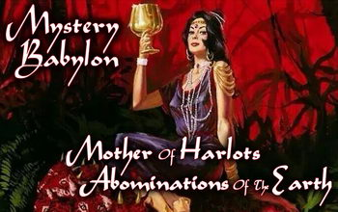

MYSTERY (5)

ILL: Def. “The Bible uses the term, “mystery” to refer to a sacred secret. It is something that had been hidden in the past but was eventually revealed. [For example], Paul wrote about the mystery of the Gentiles, or non-Jews, becoming part of the church,” https://www.blueletterbible.org/Comm/stewart_don/faq/bible-basics/question14-mystery-bible-doctrine.cfm

ILL: Definition: “An open, sacred secret; hitherto concealed, but now revealed,” (author unknown).

The identity of Who mystery Babylon is has NOT been revealed in the Scriptures. Beware of those who make wild speculations and make the Bible say more than it does. For example, one speculation is that Mystery Babylon is the USA.

ILL: “America is Mystery Babylon in Revelations chapter 17 and 18 and will be destroyed by a nerve gas attack and nuclear explosion followed by its complete destruction in a tsunami,” https://americaslastdays.blogspot.com/

Beware of people, like Chuck Youngbrandt, Dimitru Duduman, Henry Gruver, AA Alan; and organizations like Staff and Sword Ministry,
http://netofprayer.org/blog/wp-content/uploads/2016/03/1.-HISTORY-OF-THE-NET-OF-PRAYER.pdf

ILL: “Dumitru asked God why he had brought him to America. God began to show Dumitru that he was brought to America to deliver a warning about impending judgment upon the country. Hand of Help would like to offer the Body of Christ the writings of Dumitru Duduman, https://www.handofhelp.com/index.php

Summary: God has clearly revealed in the Word of God what did and will happen in the future. The apocalyptic writings in Daniel, Revelation & other books of the Bible, make the events understandable to those who believe in the Verbal, Plenary [Full] Inspiration of the 66 books of the Bible. Furthermore, many of the biblical symbols are literally identified by Jesus, in the Gospels, the book’s author, or by an author of another biblical book. In Rev. 17:9-12, an angel explains the biblical symbol to John in his vision of heaven.

However, God has not revealed all of the details that we would like to know. I believe it is sinful to make the Bible say more than it does, or less than it does. Lastly, I believe twisting the Scriptures to say something other than what God intended is wickedness. Therefore, I pray that we will be very careful with how we interpret, communicate, and apply the Holy Bible.

BABYLON THE GREAT (5)

Symbolic Babylon, not the Literal, Historical & Geographical City of Babylon, that existed in John’s Day; as well as today in Iraq.
MOTHER OF HARLOTS (5) 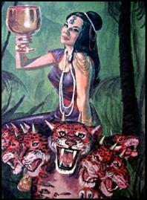

The Non-biblical, World’s Religions, who are all derived from one source; Babel (Tower of Babel), also known as Babylon.

The blood of the Saints . . . Martyrs of Jesus (6)

“Pleasure-addicted society conspires with the Power-addicted State to silence the testimony of Jesus’s witnesses by putting them to death (13:15-17),” ESVSBftn on 17:6.

Mystery [of the woman] (7)

The beast (8)

Both a King (World Ruler) and a Kingdom (World Power),
thus; a Satanic, World Leader with a Worldwide Influence / Control.

Was, and is not, and will ascend (8)

An artificial, counterfeit resurrection of the Antichrist. This is a cunning, confusing and deceptive copy of the genuine, literal and bodily resurrection of Jesus Christ.

ILL: 13:3-4, 12-14 and ESVSBftn on 13:2

Out of the bottomless pit (8)

John F. Walvoord explains, “The “bottomless pit” (Gr. Abyssos, meaning “bottomless” or the abyss) is the home of Satan and demons, and indicates that the power of the political empire is satanic in its origin, as is plainly stated in 13:4,”
(John F. Walvoord, Rev. & Ed. Philip E. Rawley & Mark Hitchcock, Revelation ( Chicago: Moody, 2011; org. 1966), 260).

Perdition (8) or eternal “destruction,” ESV.

1. Matt. 7:13 Narrow / Wide Gate
2. John 17:12, “son of destruction.”
3. Philippians 1:28, “clear sign to them of their destruction,” “Destruction (Gr. apoleia) here means eternal destruction,” ESV Study Bible footnote on 1:28.
4. Philippians 3:19, “end is destruction,” “they glory in their shame.”
5. 2 Peter 3:7, “destruction of the ungodly.”
6. 2 Peter 3:16, “the ignorant and unstable twist to their own destruction, as they do the other Scriptures,” (ESV).

Summary:

“Perdition,” or “destruction” is ultimately the _______ of _______.

Residents:

a. Rev. 19:20, Beast (Antichrist) + False Prophet
b. Rev. 20:10, Devil (Satan / that fallen angel of Isa. 14 & Ezek. 28).
c. Rev. 20:14, Death and Hades
d. Rev. 20:15, Anyone not “written in the book of life.”

Therefore:

Antichrist + False Prophet + Satan + Death & Hades + Ungodly.

Book of Life (8)

> The Names of God’s human, spiritual family.

> Seven Occurrences: Phil. 4:3; Rev. 3:5; 13:8; 17:8; 20:12; 20:15; 21:27.

From the foundation of the world (8)

God’s Pre-Creation, Redemptive Plan

Seven mountains (9)

> Seven Kings & their Kingdoms.

ILL: 17:9-11 ESVSBftn.

> Its wise to remember that the identification of every biblical symbol is not certain. Therefore, discernment says ‘avoid dogmatism where Scripture is silent.’

Seven kings (10)

Seven World Empires:

~ Egypt
~ Assyria
~ Babylon
~ Medo-Persia
~ Greece
~ Rome
~ Antichrist (Some Scholars believe it’s a Revived Roam Empire)
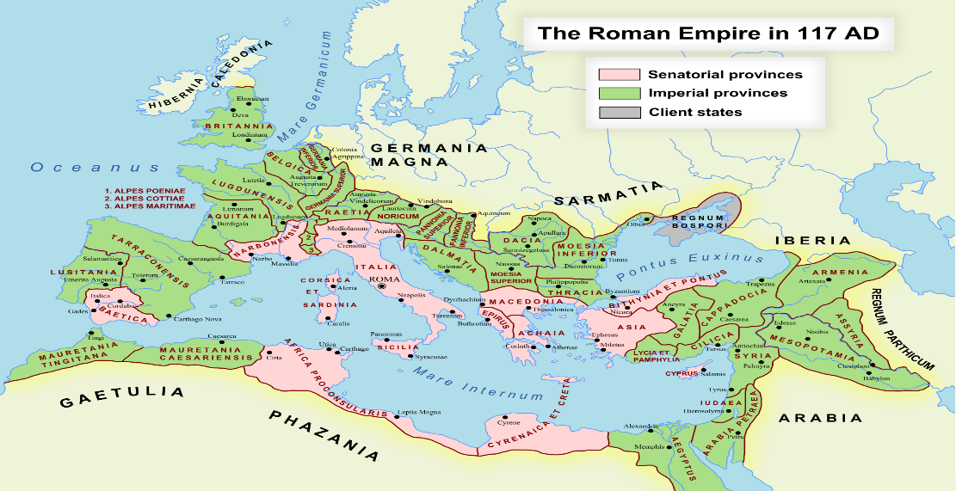
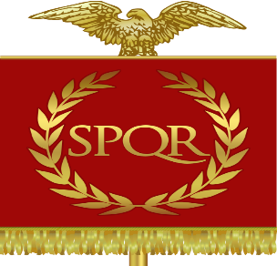

Five have fallen, one is, and the other (10)

The Apostle John wrote The Revelation of Jesus Christ in about A.D. 95 – 96. All of the World Empires listed above had come and gone except the last two. The Roman Empire endured until A.D. 476, when, “The last Roman Emperor Romulus Augustus is defeated by the German Goth Odoacer. This is the start of the Dark Ages in Europe,” (https://www.softschools.com/timelines/roman_empire/timeline_9/).

The Empire of the Antichrist was future for the Apostle John and still is future for us, the Church of the 21st. Century.

And is not . . . the eighth (11)

Self – Deification and mandated worship. ‘I am god & you will worship me.’

Ten kings (12)

Like 10 Districts or Provinces that the Antichrist will control.
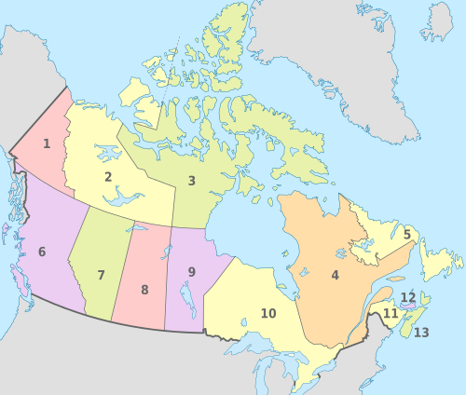
ILL: Canada’s 13 Provinces. One Country with 13 Provinces.

No kingdom as yet (12)

Scripture has not provided the 10 Kings identity. Therefore, let us avoid wild speculations and further avoid speaking loudly where and when the Scriptures are silent.

One hour (12)

> The Beast’s (Antichrist) time is measured, not endless.

> The Beast’s (Antichrist) time is short, not forever.

α. Rev. 11:2-3
30 days @ Month x 42 Months equals 1,260 days, or 3 ½ Years.

β. Rev. 12:6, 12

γ. Rev. 12:14 “time, times, and half a time”

time = 1

times = 2 (plural)

half a time is half of one = ½

Therefore, 1 + 2 + ½ = 3 ½, pointing to one half of the 7-year Tribulation, or 3 ½ years.

δ. Rev. 13:15

42 months = 3 1/2 years, or second half of the Tribulation Period.

ε. Rev. 18:10, 17, 19

“in a single hour,”

“Kings will mourn Babylon as the mighty city that God judged in a single hour (see vv. 17, 19), suddenly and swiftly, when his patience had reached its limit,”
ESV Study Bible, 18:9-10 footnote.

> Summary: ESVSBftn. 17:12-14

Make war (14)

Battle of Armageddon

Rev. 16:14-16

ILL: ESVSBftn. on 16:16

ILL: Compare Rev. 4-22 Bible Study, No. 14, p. 8.

Rev. 19:17-21

ILL: ESVSBftn. on 19:19 gathered to make war.

ILL: Compare pictures this writer shot at this location in Israel in 1995.

Lord of lords and King of kings (14)

A Title, or Name of God

ILL: 1 Timothy 6:15
Rev. 17:14
Rev. 19:16

Verses 16 – 18
Babylon’s Fall Lamented and Celebrated (17:16 – 19:10)

These will hate the harlot (16 - 17)

Turning on one another

ILL: Like 3 criminals who attack the Police, then murder one another.

Great City (18)

Who or What is this?

ILL: Rev. 18:10, 18, and 21.

ILL: Here is a mini-Bible Study to help.
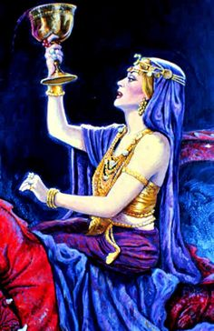
The Woman of Revelation 17
A Lesson on Understanding Symbolism

Revelation 17:3
And he carried me away in the Spirit into a wilderness, and I saw a woman sitting on a scarlet beast that was full of blasphemous names, and it had seven heads and ten horns.

Revelation 17:4
The woman was arrayed in purple and scarlet, and adorned with gold and jewels and pearls, holding in her hand a golden cup full of abominations and the impurities of her sexual immorality.

Revelation 17:6
And I saw the woman, drunk with the blood of the saints, the blood of the martyrs of Jesus. When I saw her, I marveled greatly.

Revelation 17:7
But the angel said to me, “Why do you marvel? I will tell you the mystery of the woman, and of the beast with seven heads and ten horns that carries her.

Revelation 17:9
This calls for a mind with wisdom: the seven heads are seven mountains on which the woman is seated;

Revelation 17:18
And the woman that you saw is the great city that has dominion over the kings of the earth.”

Summary:

Therefore, this dressed up, drunken, and seated woman is a renowned city,
called the “great city,” (ESV).

Your Reflections & Responses?

